***ANSIBLE***

We have deployed our app and now we have to update on service level but not as infrastructure level. We need to update from nginx level (service level) so, **in such case Terraform will not use but initially we can do by file provisioning. But mostly Terraform is not for this case, Terraform will use For Infrastructure Automation.**

**Configuration & Desired State:**

I want to install ngnix and configure it -🡪 configuration state

I want to make sure this config does not change -🡪 Desire state

**Tools for Linux:**

Chef and Puppet and Ansible and Salt

**Tools for Windows:**

SCCM (System Center Configure Manager) and Power shell DSC (it will implement the configuration and if any one changes the configuration we can re-run with old configuration)

**Ansible Vs Puppet:**

Ansible 🡪 1. No Agent needed and works on SSH and Open source and Free.  
 2. we have Ansible Tower which is paid.   
 3. Not Complex   
 4. It pushes the Configurations

Puppet 🡪 1. Agent Based and works using puppet agent.  
 2. Agent pulls the configuration.

**Groups and Variables:**

1. **Variables from Play book:** If we variables in Playbook that has the 1st priority.
2. **Group_vars/all** : If we give variables outside of playbook then variables will pick from group_vars/all file.
3. **Group_vars/websrvgrp:** websrvgrp is the same name that we have in inventory file.Suppose if we have variables in **Group_vars/all** and   
    **Group_vars/websrvgrp** then priority goes to **websrvgrp** file.
4. **Host_vars/web02:** Among **Group_vars/all** and **Group_vars/websrvgrp** and   
    **Host_vars/web02** then priority goes to **Host_vars/web02. i.e,**  web02  
    will pick up variables from host_vars.

**Cycle priority:**

**Playbook** 🡺 **Host_vars/hostname 🡺 group_vars/group_name 🡺 group_vars/all**

Among all these the top most priority is cmd line, this is mainly used for testing purpose

Ex: ansible-playbook -e USNM=cliuser -e PASS=clipassword example.yaml

**User_guide:** <https://docs.ansible.com/ansible/latest/playbook_guide/playbooks_variables.html>

**Fact Variables:** ansible-playbook -m setup web01

This setup module runs as a tool called as “**Ohai**” This tool collects system information in a JSON format.

**Decision Making:**

<https://docs.ansible.com/ansible/latest/playbook_guide/playbooks_conditionals.html>

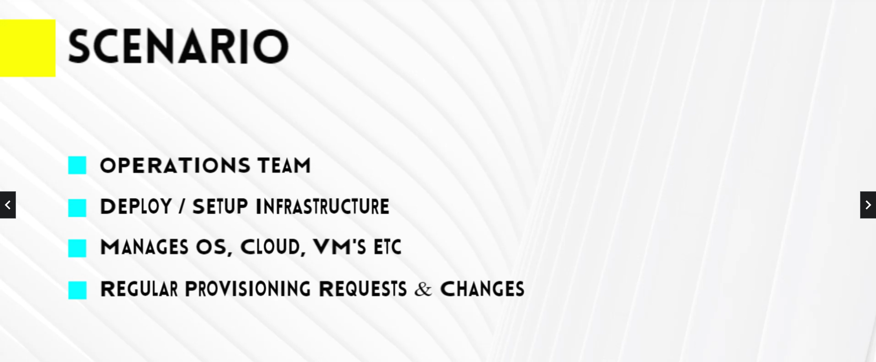

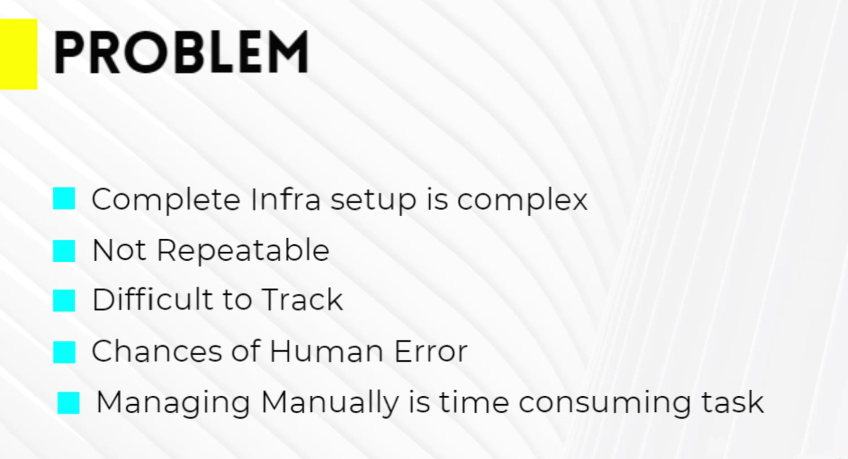

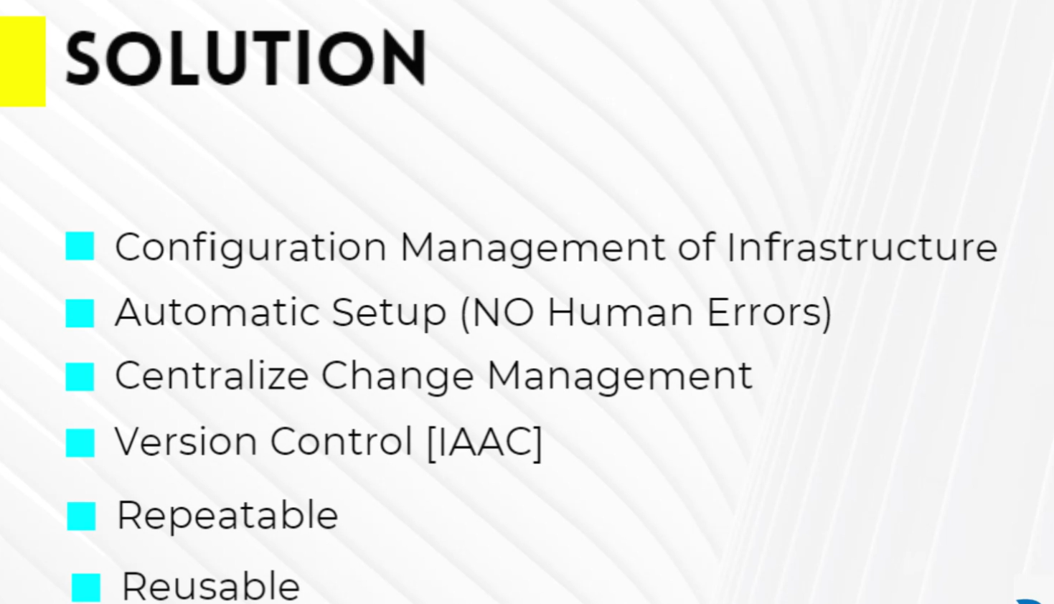

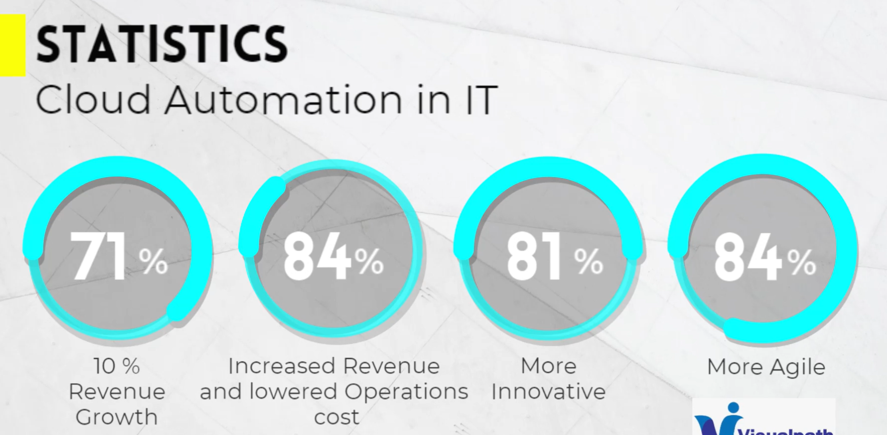

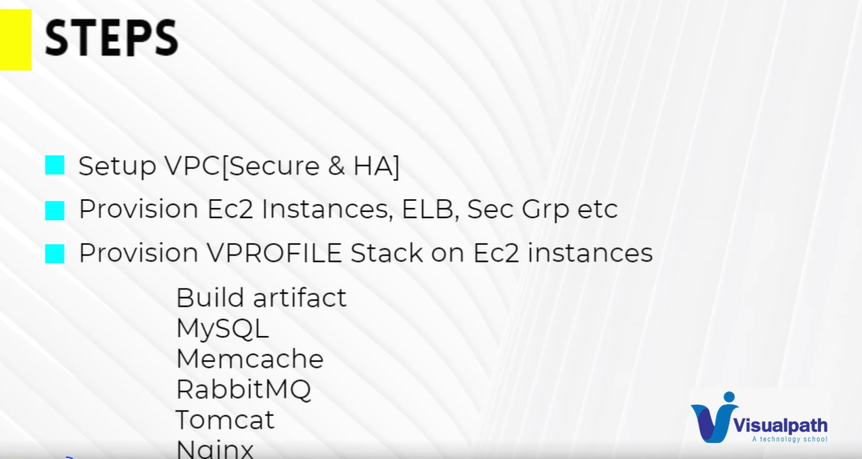

**VPC  
  
